**JENKINS SETUP**

**Pre-requisites:**

**Minimum:**

1. 1 GB RAM
2. More than 20 GB Disk

**Installation Platforms :**

* Windows
* Linux (Any Distro)
* Docker (It must require either Windows or Linux based OS)
* Kubernetes (It must require either Windows or Linux based OS)

**Docker Installation :**

Please refer to the Docker Installation documentation to set up a docker engine for Linux and Windows based systems.

Follow the below procedure to set up a Jenkins as per your required platform.

→ **Jenkins on Docker:**

1. Create a separate network for Jenkins which would allow Jenkins to access your Docker host for their tasks without any issue on the same network.

Note: (You can use the default bridge network if you want but separate network is recommendable)

|  |
| --- |
| docker network create jenkins |

1. Create a docker volume directory to store your data on your local host for Jenkins storage as you lose your jenkins data when docker terminates the container.

Note: /var/docker/volumes is a path where the below command creates a directory for your storage.

|  |
| --- |
| docker volume create jenkins-data |

1. Execute the below command to create the Jenkins container along with the accessing port which you want.

|  |
| --- |
| docker run --rm -d -name Jenkins -p 50000:50000 -p 8080:8080 -v jenkins-data:/var/jenkins_home -n jenkins jenkins |

1. Once done above steps, you can access it via your browser

|  |
| --- |
| http://localhost:8080 |

→ **Jenkins on Windows**

1. Set up the Java JDK installation and Path set up first (refer the Java JDK Installation documentation)
2. Download the <http://mirrors.jenkins.io/war-stable/latest/jenkins.war> to an appropriate directory on your machine.
3. Open up a terminal/command prompt window to the download directory.
4. Run the below command

|  |
| --- |
| Java -jar jenkins.war |

1. Once done above steps, you can access it via your browser

|  |
| --- |
| http://localhost:8080 |

→ **Jenkins on Linux: Ubuntu Distro**

1. Install the repository for Jenkins packages and binary for Installation

|  |
| --- |
| wget -q -O - https://pkg.jenkins.io/debian-stable/jenkins.io.key | sudo apt-key add - |

|  |
| --- |
| sudo sh -c 'echo deb https://pkg.jenkins.io/debian-stable binary/ > \  /etc/apt/sources.list.d/jenkins.list' |

1. Update your system first before you do anything else. Run the following commands:

|  |
| --- |
| apt-get update && apt-get upgrade |

1. Install the required package if you don’t have it already installed

|  |
| --- |
| apt-get install software-properties-common |

1. Use the below command to install Jenkins

|  |
| --- |
| sudo apt-get install jenkins |

1. Start and enable the Jenkins service as a system startup.

|  |
| --- |
| sudo systemctl start jenkins |

|  |
| --- |
| sudo systemctl enable jenkins |

1. Once done the above steps, create a jenkins user for Jenkins to interact with your host.

|  |
| --- |
| Adduser jenkins |

1. Change the ownership for the directory as jenkins user name to interact with Jenkins.

|  |
| --- |
| Sudo chown jenkins:jenkins <Directory-name> |

**Post Installation:**

Browse the URL <http://localhost:8080>(port which you assigned) on your browser and follow the below steps.

1. Below snap is the page you would get to provide the administrative credential which you can find it on this path /var/jenkins_home/secrets/initialAdminPassword

Note: This is for one time, so just copy and paste the credentials.

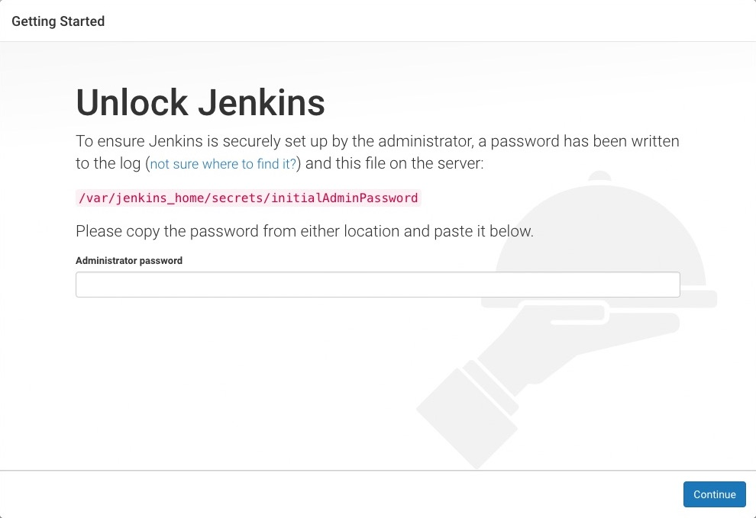

1. Next step, just choose the Install Suggested Plugins option to automatically install all the required plugins for your Jenkins tasks.

Note: There is an option to manually install this via (Manage Jenkins → Manage Plugins → Choose available option and search the plugin which you want → Select Install without restart).

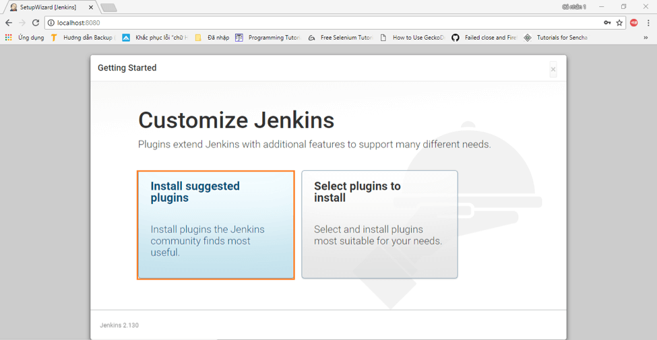

1. Next, just create the admin user with Username and Password to access and manage the Jenkins dashboard.

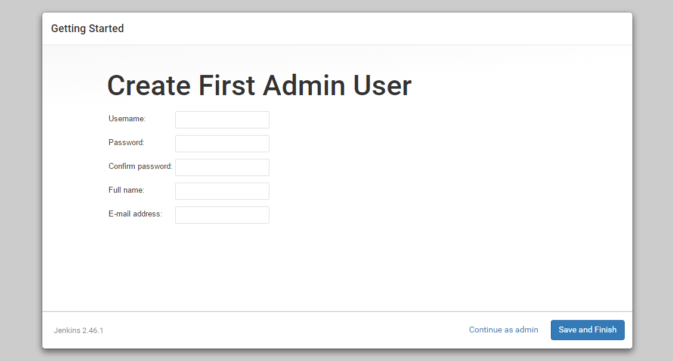

1. Once everything is done, you are all set to go and access the Jenkins dashboard.



